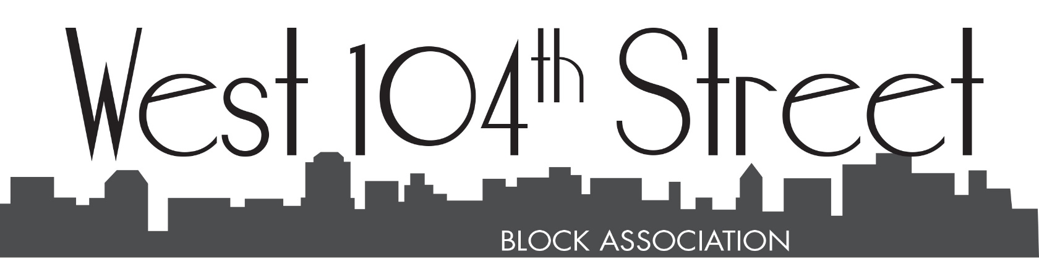2025 Treasurers Report
Dear Neighbors-
Income
The income received in 2024 was $69,447.76.
Dues paid by block residents are the major contributor to the income. I will point out that we received dues from off-block residents who appreciate and identify with the block association’s initiatives, such as the security guard. Total dues collected were $26,552.43
The Income Pie Chart shows the annual yard sale as another major contributing factor at 26% of the total income. However, this is a bit misleading – the yard sale gross intake was $17,880.19 but the expenses were $8,775.18 which leaves a net income of $9,105.01.
Contributions include the cooperative buildings that provide a yearly stipend. The year the total was $10,684.06. Other contributions include individual residents contributing to an initiative such as beautification or rodent control that is above the $175 recommended dues payment. In 2024, this amounted to $7,693.95.
Other income sources include newsletter ads, the selling of merchandise, and various activities, such as Bloomingdale Bites.
Expenses
Expenses incurred in 2024 totaled $69,644.77.
The major expense is the security guard who patrols West 104 Street between WEA and RSD 6 days per week between 6PM and 11PM. The cost for the year was $39,504.60.
Other major expenses include beautification of the block with tulips in the fall, planters on some t ree beds, summer flowers, tree maintenance of fertilization and trimming ($10,677.35), the production of our block quarterly newsletter ($2,892.06), the cost of activities and merchandise ($4,261.07), and the aforementioned yard sale cost. Ther operating and legal costs totaled $1,286.68.
We deeply appreciate your involvement and contributions to the block association. We are privileged to have an active block association and a wonderful community that encompasses more than West 104th Street.

